Appendix B. Parameter Screen Layouts

Credit Card Interface:

Credit Card Balancing Report
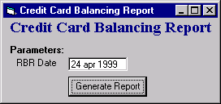

Credit Card Imbalance Report
